# Artefact 1:

## Sprint 1

## Building the server

We were told we had to use a SQL database and while not needed it would be nice if it was live, so I build a live server on digital ocean. The server is using a LAMP stack which consists of Ubuntu 16.04 with an Apache webserver and MySQL and PHP for backend and database stuff. While doing this was a good idea at the start I soon found out only one person could connect to the server at once which was problematic and I had a lot of security issues.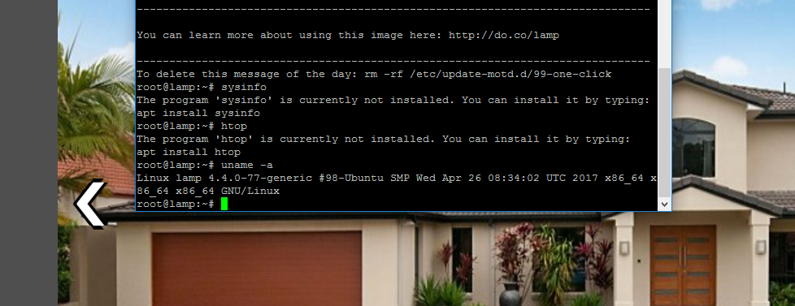

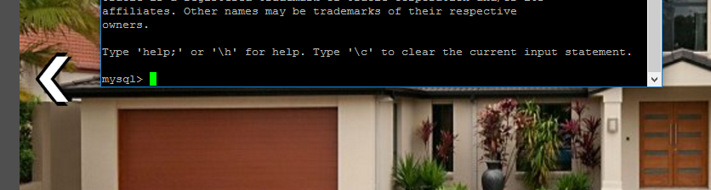

I also installed phpmyadmin to make it a bit more user friendly:



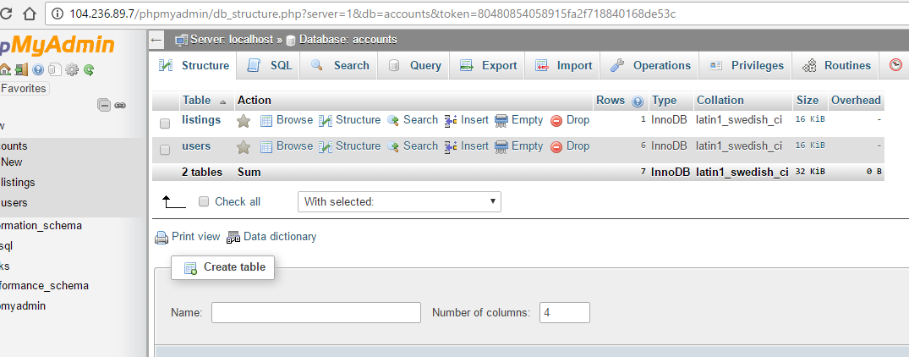

# Artefact 2:

## Sprint 1

## Building the database:

We decided to have two tables within the database one with users and their information and the other with listings or houses and their information. I linked these two tables together with a forging key between there id from users table and owner on listings table. Passwords were hashed with a salt and data was all special character protected.

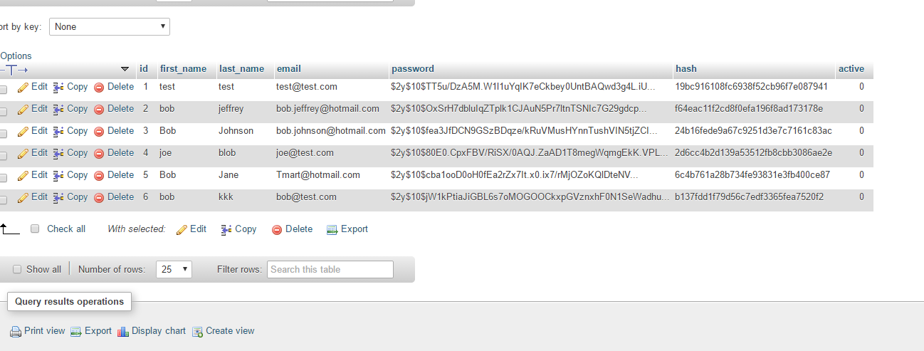

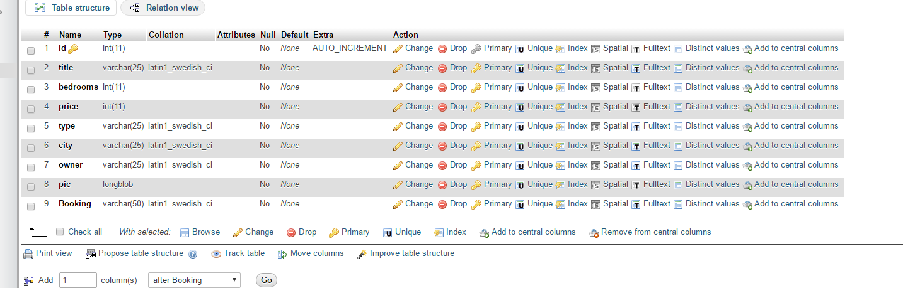

# Artefact 3:

## Sprint 1

## Connect to database with PHP:

I only could find two libraries or helper files? which helped with connecting to a MySQL database, these were MySQL and PDO, I went with MySQL because it looked easier and PDO is about 15 years old shout out to 230. MySQL was very helpful it allowed you to store session variables so you can keep track of users and there properties.

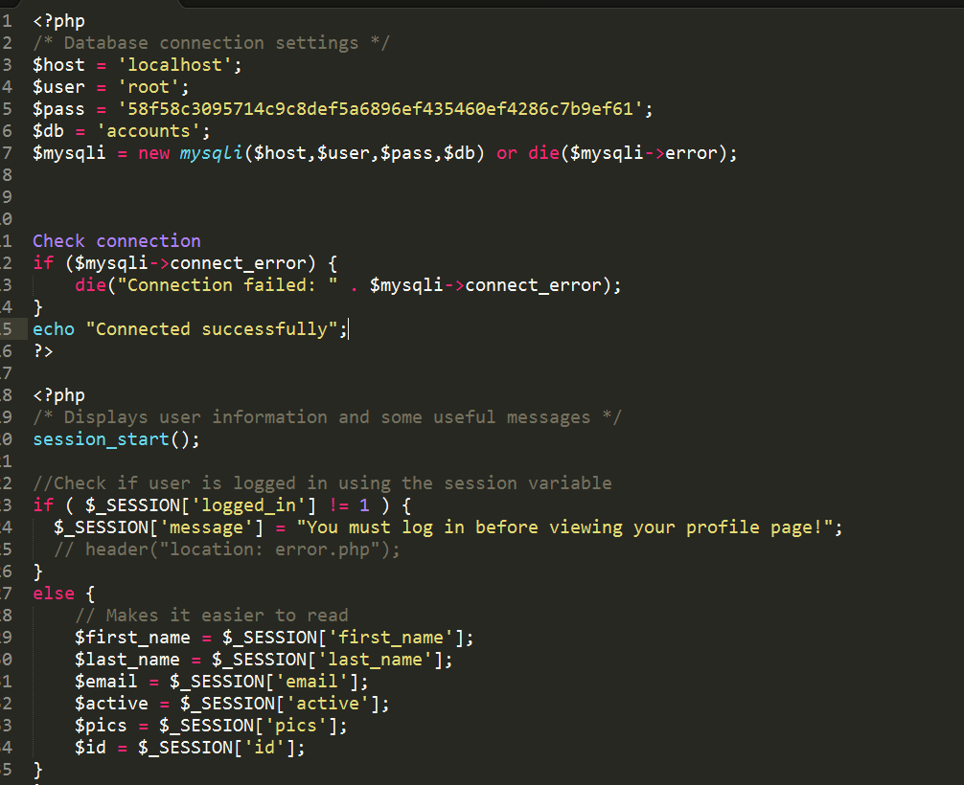

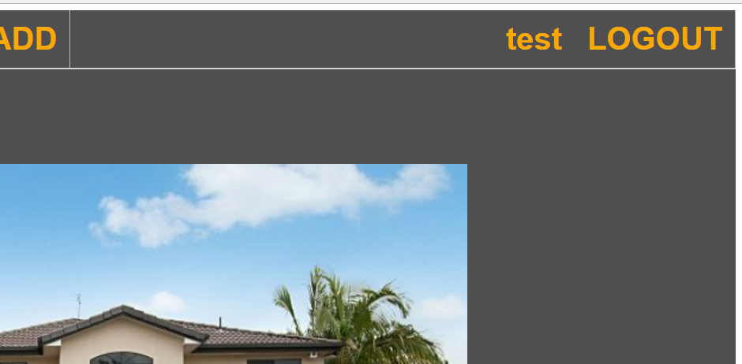

# Artefact 4:

## Sprint 2

## User stories:

One of our user stories was a view counter for the website to show how many hits the website has had and if the website was busy or not. I used JavaScript to write a function to keep track of how many times the rage was refreshed.

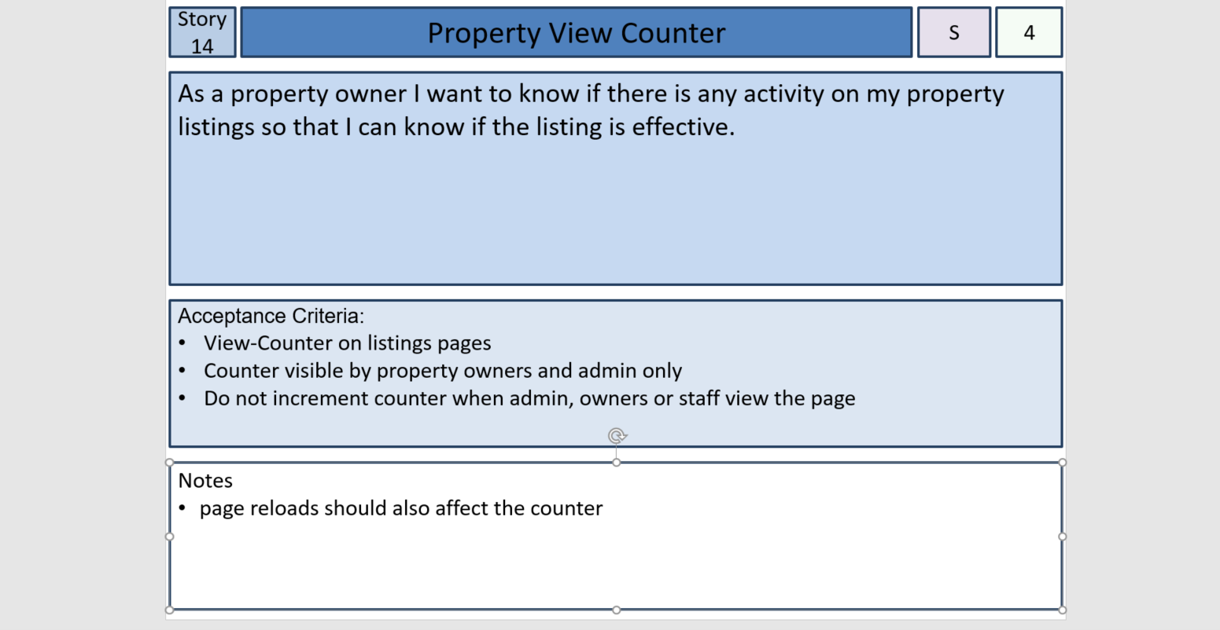

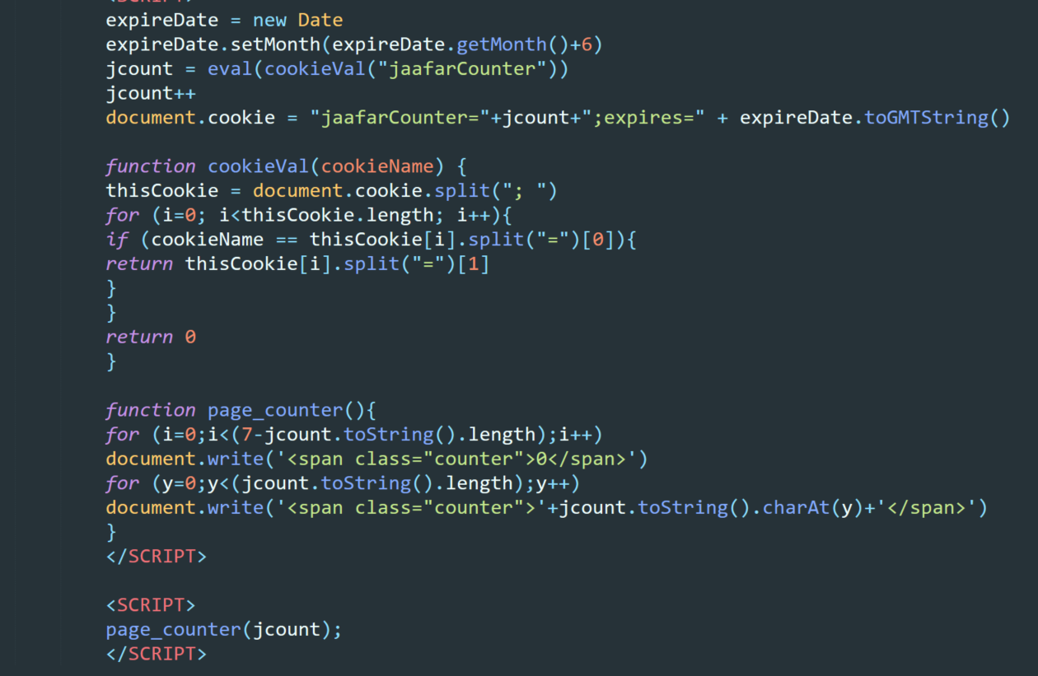

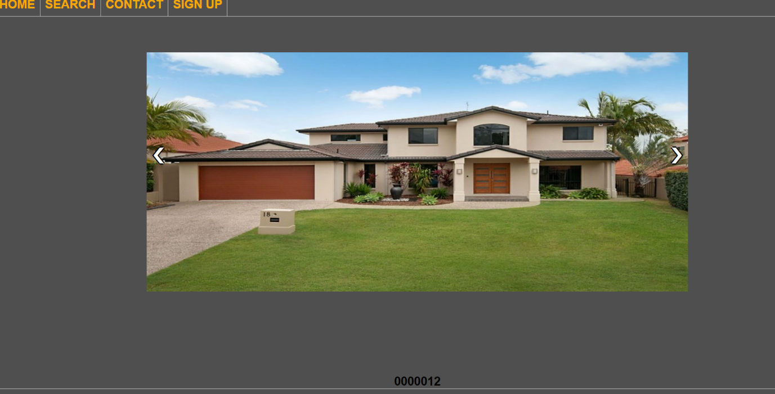

# Artefact 5:

## Sprint 1

## More website design:

Made basic design of website including header, footer, body and navbar others did help with styles and colours.

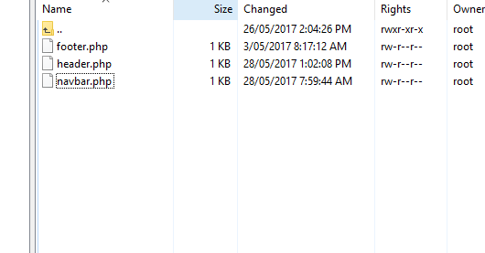

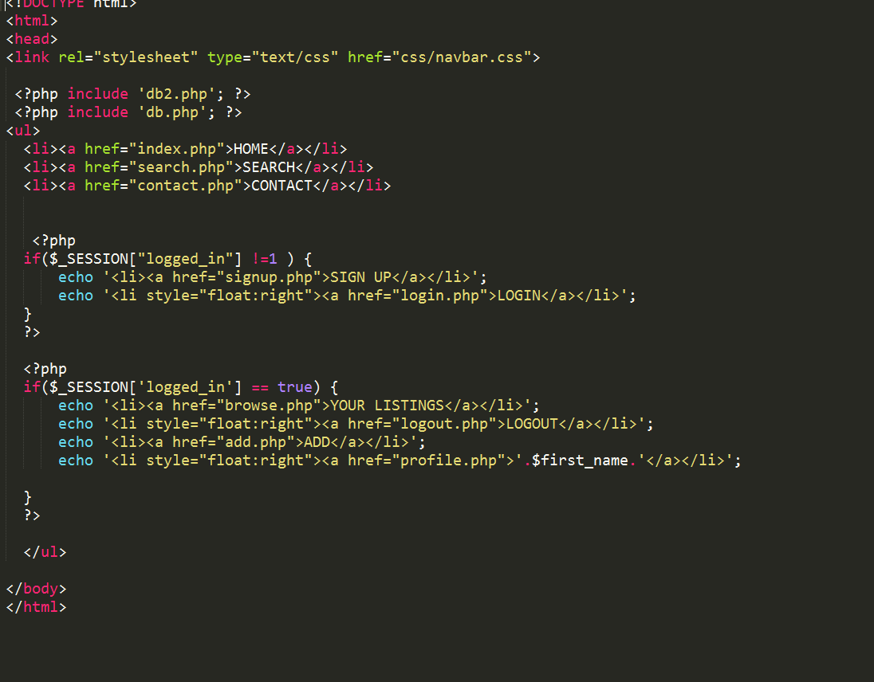

# Artefact 6:

## Sprint 2

## Add form:

Made the add page which allowed the user to add a housing to the listings in the database, this page had me stuck for about two weeks because I couldn’t upload an images without an error showing up. I solved this by changing PHP and SQL versions until it worked.

The Add Page

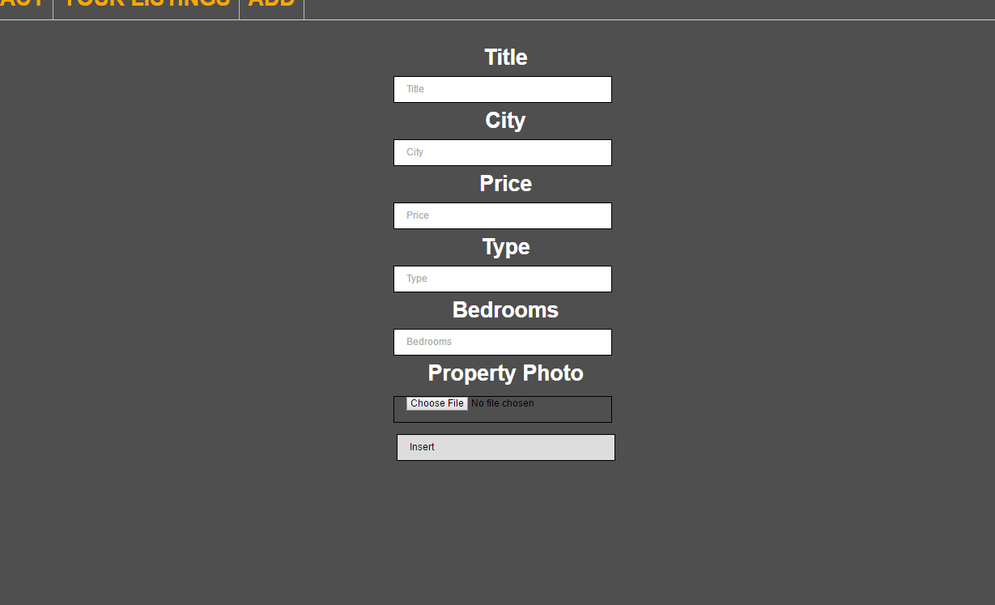

The things in the database

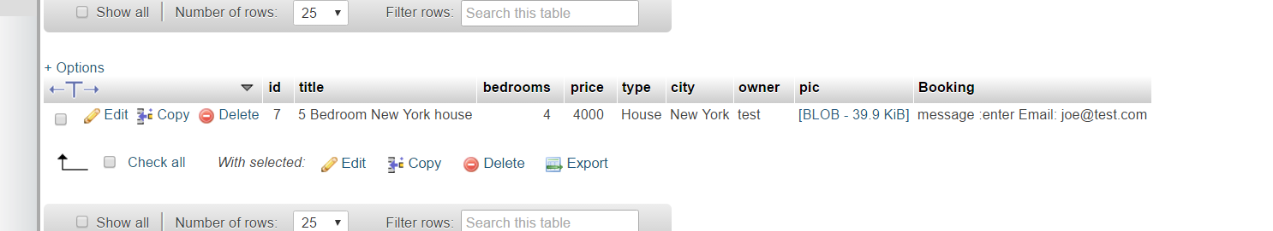

The things on the website

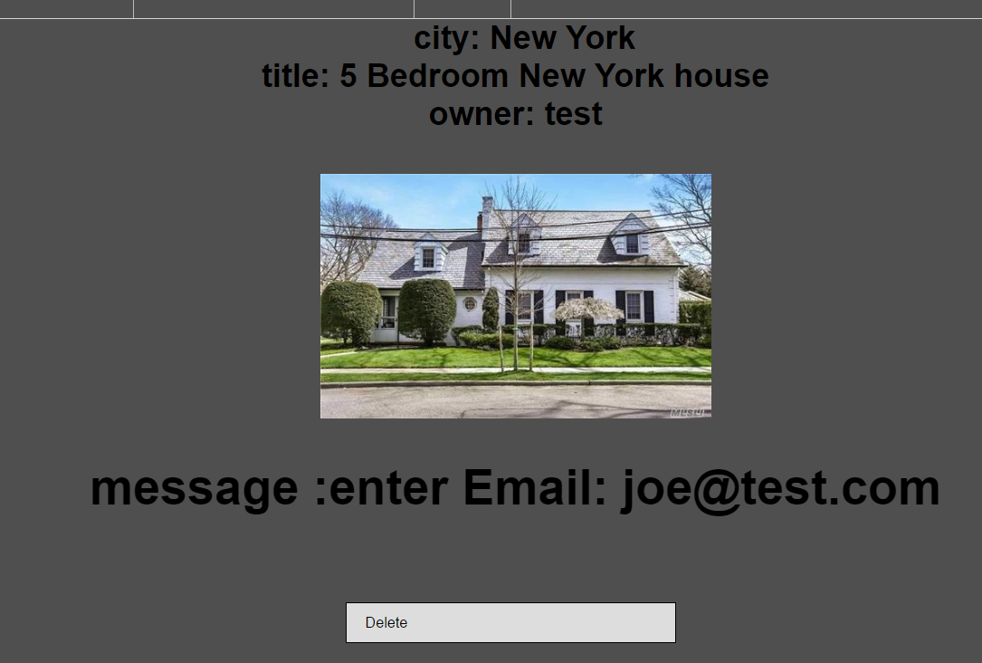

# Artefact 7:

## Sprint 2

## The search page:

Made the search page where you could search for a houses by a city name, this was done by using a simple SQL Like statement which took the post and search for anything LIKE that in the database. Would like to make this a little better because right now it returns way too much.

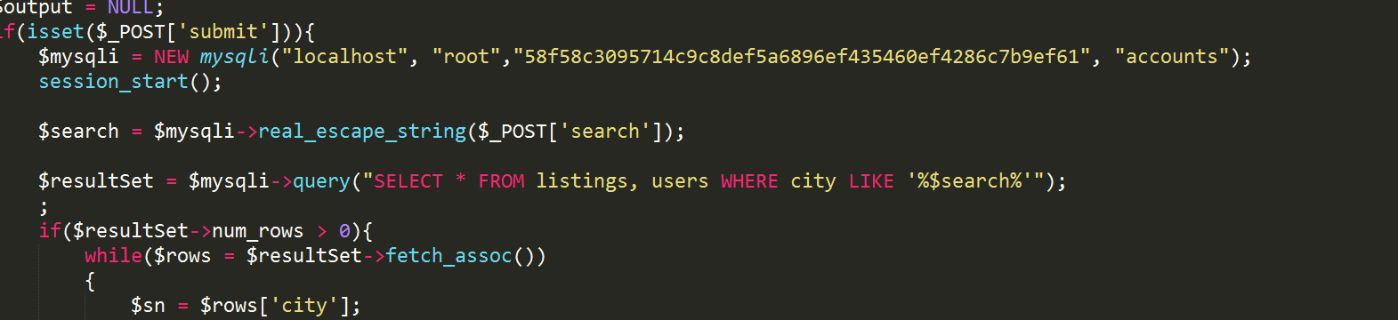



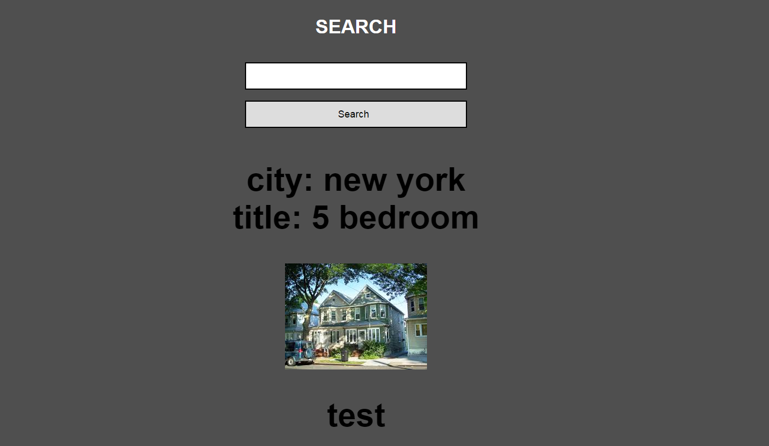

# Artefact 8:

## Sprint 2

We needed a booking feature where you could message the person if you liked there listing and it would send a message to their account and their email address.





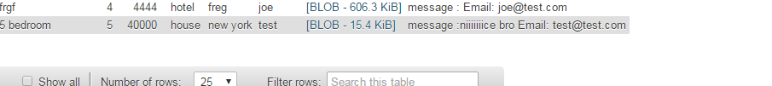



# Artefact 9:

## Sprint 1

## User stories:

Another one of our user stories was to add a star rating system to each listing, this star rating system was 1 to 5 and a user needed to be log in to make a rating. I had a lot of trouble with the CSS so mind the ugliness.

The user story:

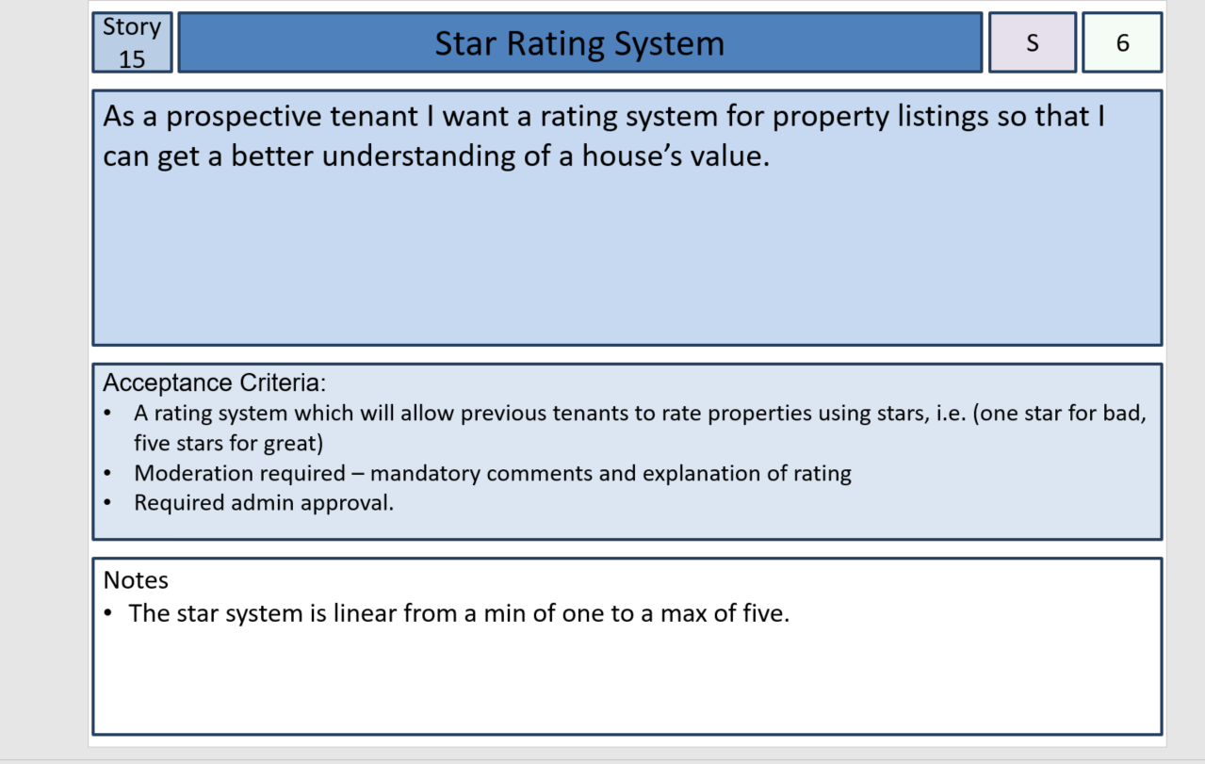

The code:

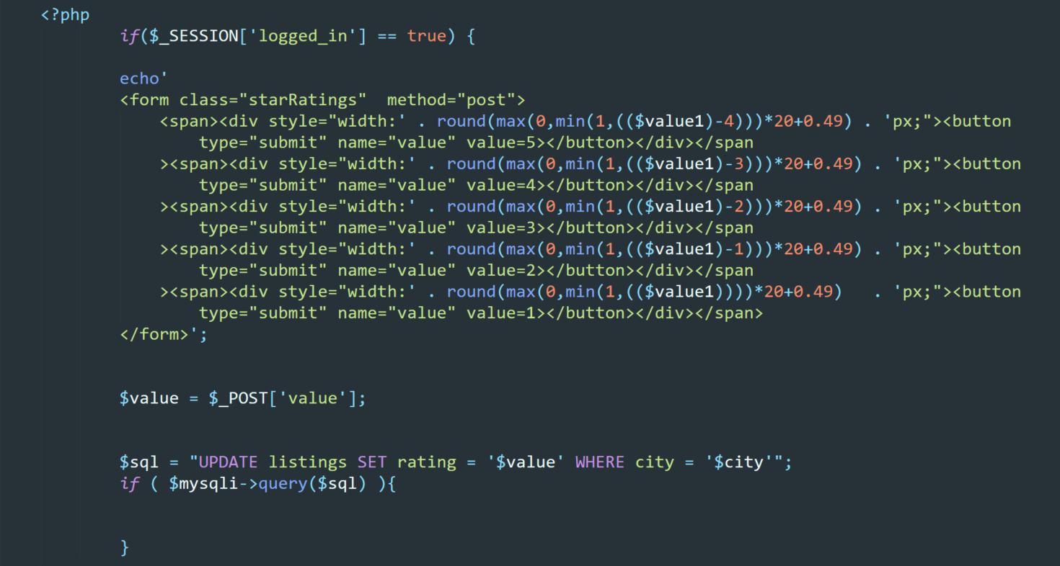

On the website:

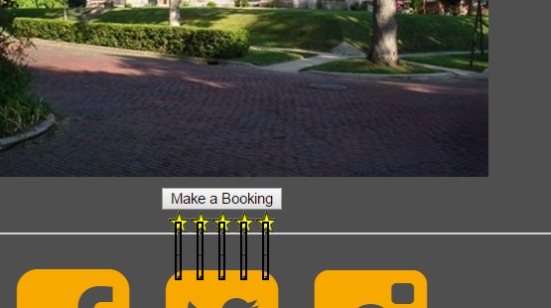

# Artefact 10:

## Sprint 1

## Beta Website:

Before knowing we had to use a SQL database I started to build the website with angular 2 having firebase as my database. This was scraped early because of said SQL database but some of the code was used in the final website.

